

Issued on: 19/06/2026 Enrollment on: 2402106051

Internship Completion Certificate

This is to certify that MAYANK SOLANKI successfully completed internship with grade A for Python With Data scinence conducted by Vibrant Technology from 01/05/2026 to 15/06/2026 at 801, Silicon Tower, Law Garden, opp. Axis Bank, Ellisbridge, Ahmedabad,.

Certified by:
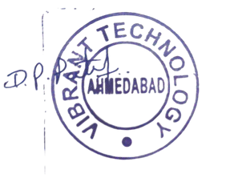

Mr.Dipen Patel
CO - Founder

info@vibrantwebtech.in  +91 8511110213

801, Silicon Tower, Law Garden, opp. Axis Bank, Ellisbridge, Ahmedabad, Gujarat 380006

